Session 2 - My First Scratch Game – Make the Monster Cry

**Step 1:**

In the File menu, select ‘New’ to start a new game. This gives you a screen with a single ‘sprite’ (Scratchie) and a Stage. You can select a different sprite if you like.

**Step 2:**

The first thing you are going to do is make Scratchie walk around the screen when you use the arrow keys. You can do this easily by giving him the script in the center box below. You will also want to choose the small box next to Scratchie’s picture in the middle that looks like 🡨🡪. The yellow parts of the instructions are from the control part, dark blue from motion and light blue from sensing. Keep adding parts until yours looks like mine. Once you have the script looking like the above, give it a try! Click the green flag and then use the arrow keys to move him around.

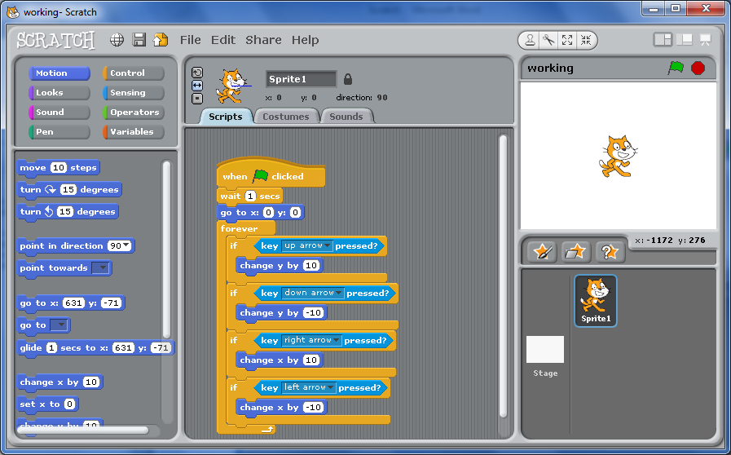

**Step 3:**

Add a costume to Scratchie. You can do this by either ‘Import’ing a new image or you can edit Scratchie directly. I decided to give him a hat. I created this using ‘Edit’ and then just using the drawing and filling tools on that screen.

Now, let’s add a background to make this look better! Click on the stage (bottom right). Just like with Scratchie, you get a choice of stuff to do in the middle. First choose ‘Backgrounds’. Here we can create our own background (using ‘Edit’) or use one of the backgrounds that came with Scratch by selecting ‘Import’. I selected ‘desert’ but you can select whatever you like. Now, as Scratchie walks around, he is doing it in the desert (wearing a cool hat).

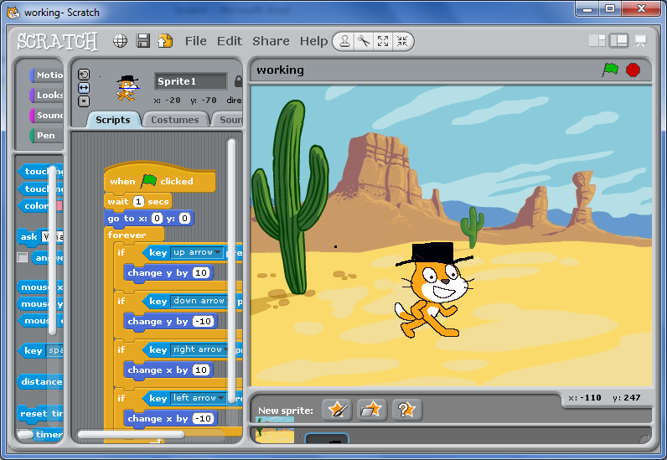

**Step 4:**

To make this more interesting, we are going to add another sprite and tell it how to behave. In the bottom right area, you can choose to ‘Import’ a new sprite. I chose one of the monsters and then used ‘Edit’ to make him smaller on the screen.

Once you are happy with the way he looks, we can give him a script to tell him how to behave. In the script shown in the next picture, I have him appear at a random place on the top of the screen and then move down the screen. The ‘pick random’ part of the ‘go to x’ is one of the Operators. Try this out. Notice that nothing happens when the two sprites touch – but we are going to change that.

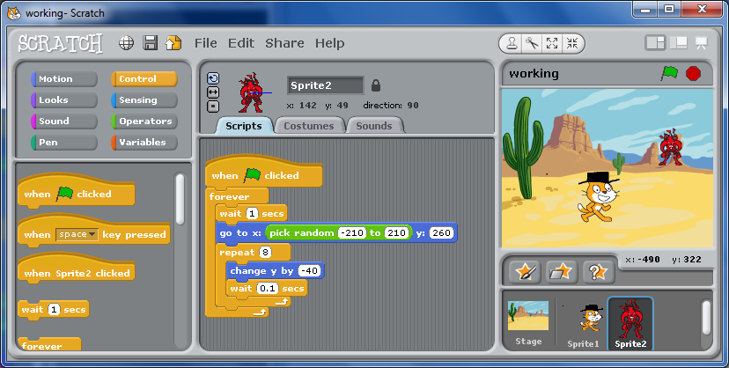

**Step 5:**

With a few small changes, we can make the monster cry and disappear when Scratchie touches it. First, choose ‘Sounds’ and import a sound – I choose BabyCry. Then, go back to ‘Scripts’ and add a few lines to Sprite2’s script, as shown below. Now, when you start the game (by clicking the green flag), try to touch the monster with Scratchie!

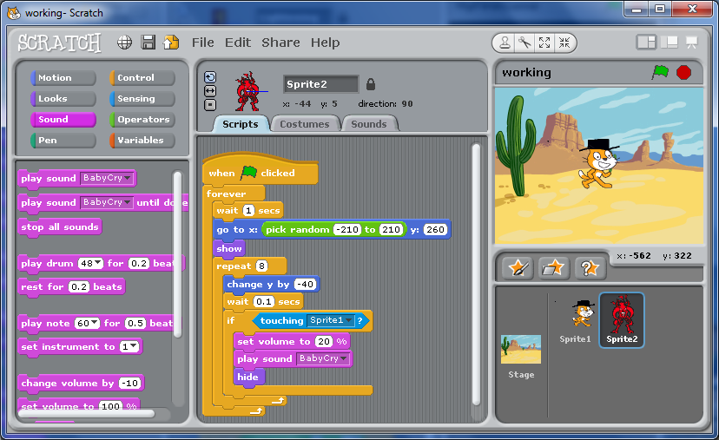

**Extra Challenges:**

* Make another sprite called “Chaser”. Have him start at -210, 210 and have her try to catch Scratchie.
* Count how many times “Chaser” catches Scratchie (hint: Variables)
* Stop the game and show “Game over” when Scratchie is caught 5 times